CMD is the command which executed during container creation

RUN gets executed during building of an image

SET 1) First make a Dockercontent folder

Mkdir Dockercontent

Ls

Cd Dockercontent

SET 2) Go inside Dockercontent folder and create a docker file

Touch Dockerfile

Vim Dockerfile

SETP 3) Insert the content

Press I for insert

Type the content

FROM Ubuntu

RUN apt-get update

CMD [“echo”,”The Docker container is running…”]

Press escape den type :wq! To save and quit

Cat Dockerfile – to see the content

SETP 4) Build the docker file

Docker build –t dockerimg:1.0.0 .

Docker images

Docker run <image id>

Now we are creating dockerfile for our project. Make sure content available in same directory

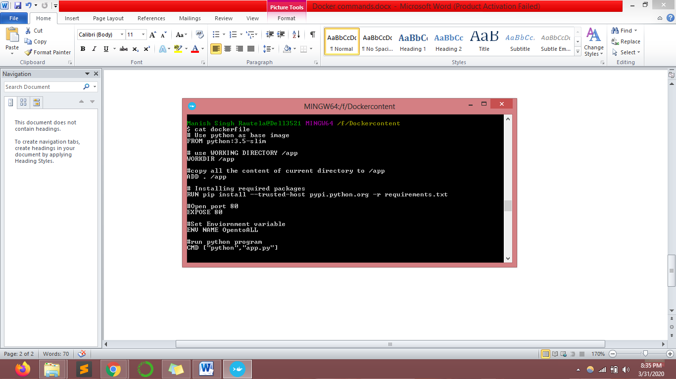

Command to creater docker image

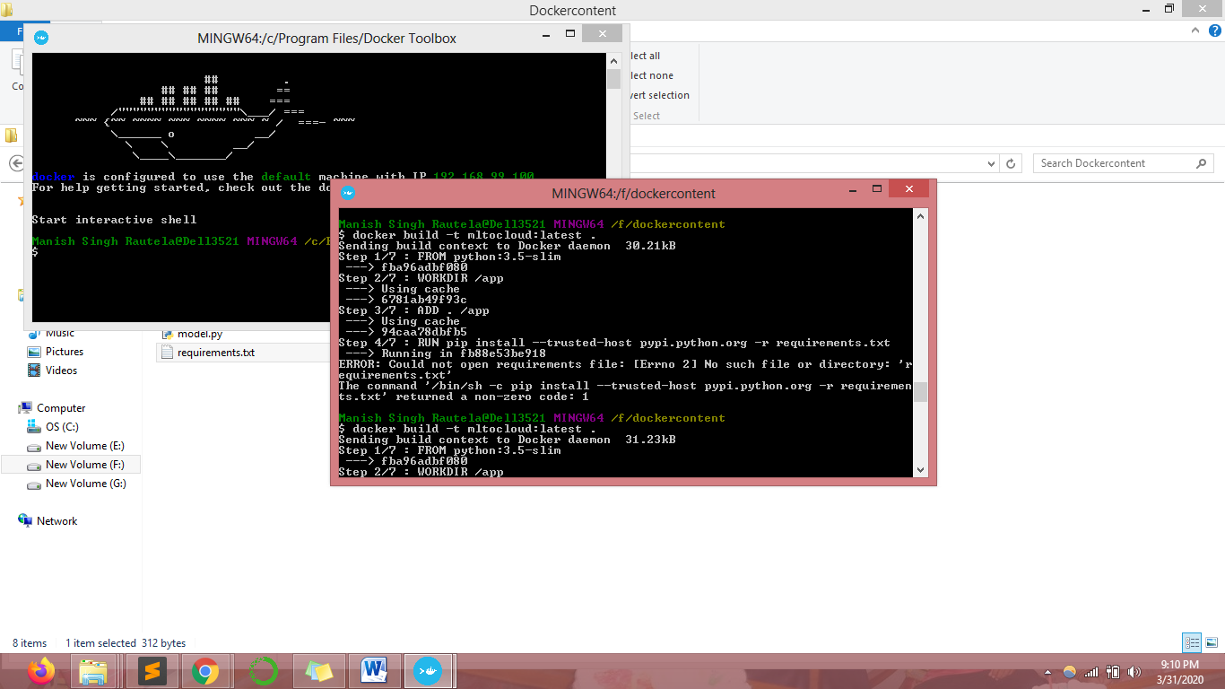

Docker images – to check our newly created docker image

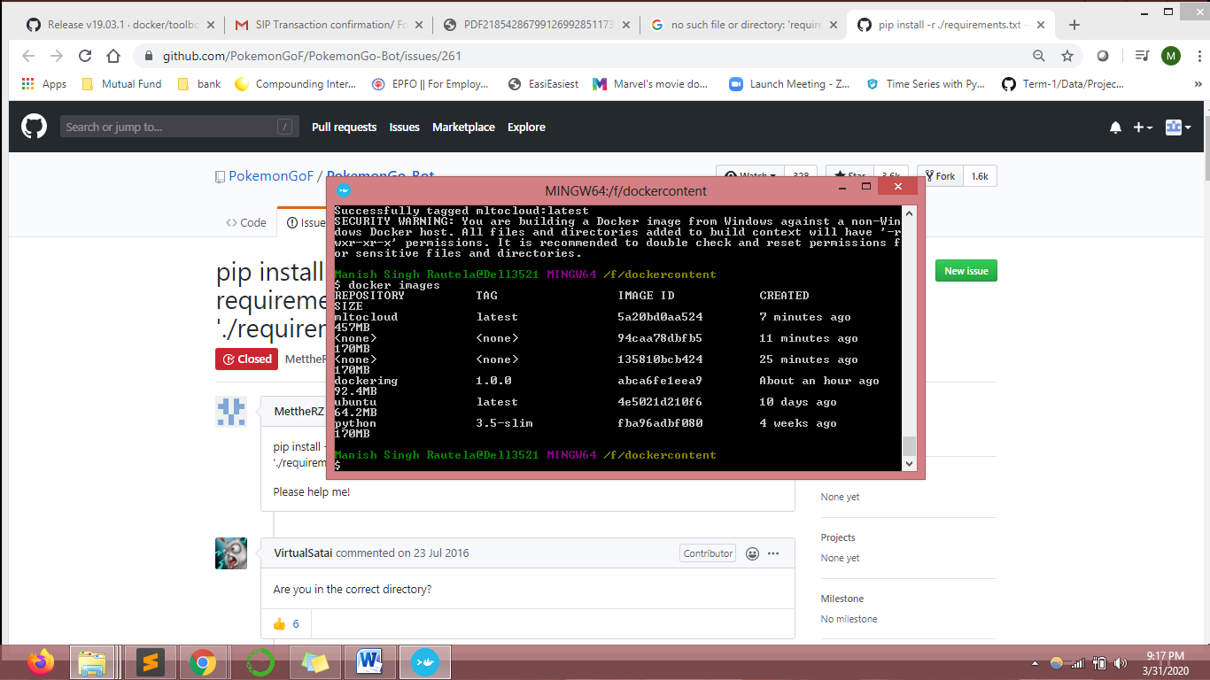

To run and check our newly created docker image in local system.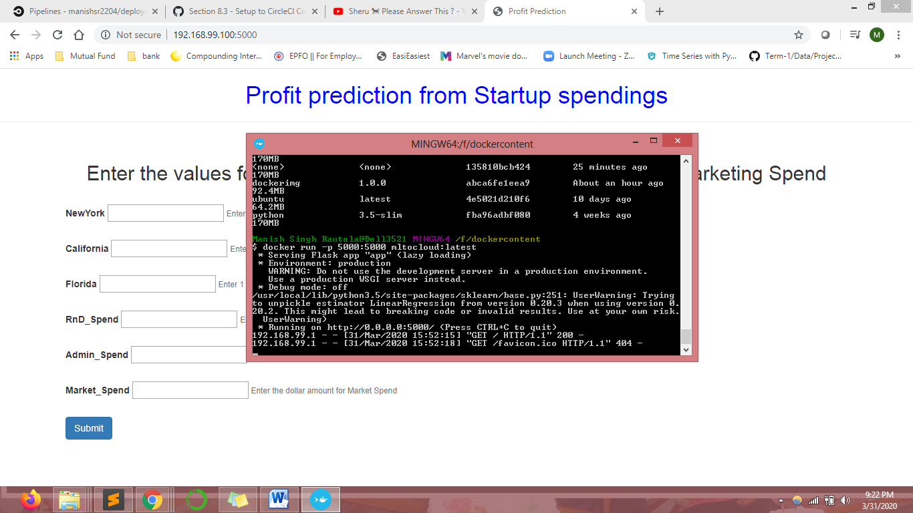

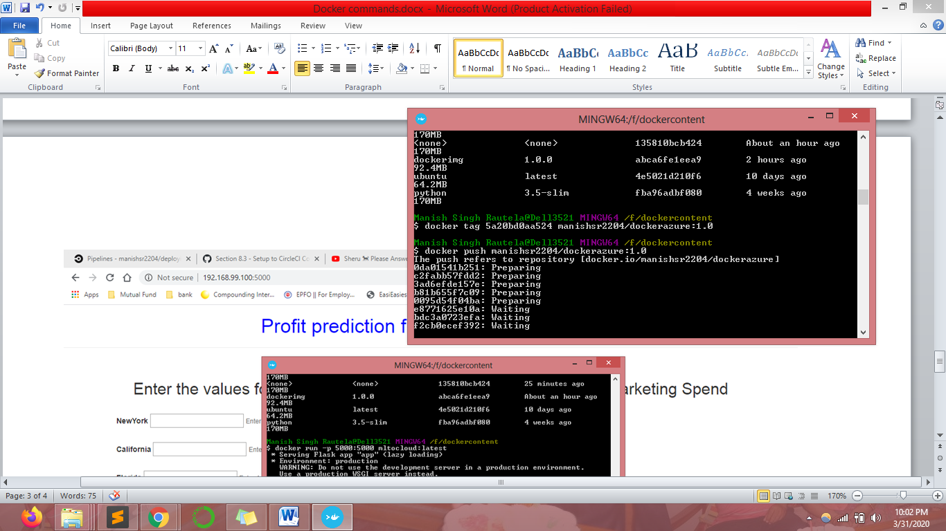

Create a repository in docker hub account after that tag and push the image to reposiroty

